Backend architecture

The Stack:
Python
Flask
MySQL

I chose Python, Flask and MySQL. The system has two applications. The first uses Python to pull the data and clean it, checking for duplicates, signs of dirty data and missing fields. It then loads the data into MySQL through a data pipeline, organised so the same fact is never stored twice this is called 3NF, and it also meets a stricter version called BCNF. The second application is a small API that reads from that database.
I chose Flask because the API is small and read-only, and a lightweight framework let me spend my time on data handling instead of framework setup. With more time I’d look at Django, which comes with a built-in way of working with the database and an admin page.
I chose MySQL because I’m familiar with it from my coursework, it supports everything the design needs, and the data is small and relational.

MYSQL
The database has two tables. In the sightings table, each sighting’s ID from the API is the primary key (the unique label for each row, which stops the same sighting being stored twice). The species table holds each species name and its Latin name, and each sighting points to its species through a foreign key (a link between the two tables). I split it this way because the Latin name depends on the species and not on the individual sighting, so keeping it in sightings would store the same Latin name hundreds of times and break 3NF.
The species table uses the name itself as the primary key, because there are only a handful of species and they’re stable. With more species, or names that might change, I’d use a numbered key instead.
I stored dates as DATETIME. The API doesn’t give a timezone, so I treat them as UTC. Location stays as plain text in the sightings table, because nothing else depends on it, so the table is still in 3NF.
I added indexes (like the index at the back of a book) on date, and on location plus date, the columns used for filtering, so searches stay fast as the data grows.

Flask (the API)
When someone sends a request, Flask reads the data they asked for from MySQL and sends it back as JSON, a simple text format that other programs and websites can read. It never calls Elanco’s API directly, only my own database, so it keeps working even if their API goes down.
The code is split into two files. app.py handles the web requests: it checks the input (dates, limits and the allowed options) and returns a clear error if something is wrong. db.py holds all the database code, so the routes never contain SQL.

The two-app split
I split the system into two applications. The data_cleaner application fetches the data, cleans it and loads it into MySQL. A separate API query application only reads from MySQL. They share the database and no code.
I did this for three reasons. First, if Elanco’s API goes down or rate-limits me, only the data_cleaner fails and the API query app keeps serving the last good data. Second, it’s easier to troubleshoot, because each app does one job. Third, they run on different schedules: the data_cleaner runs occasionally, while the API query app answers requests all day.
The trade-off is that the shared database couples them, so a change to the tables affects both apps.
For this submission I kept both apps in one GitHub repository, in two separate folders, so it’s easy to review. With more time, I’d make each one a fully self-contained project in the same repository, with its own dependencies, settings and README, so they can be run and deployed independently.

Application one (data_cleaner)
The data_cleaner is designed to run daily, and re-running it is safe
Figure 1
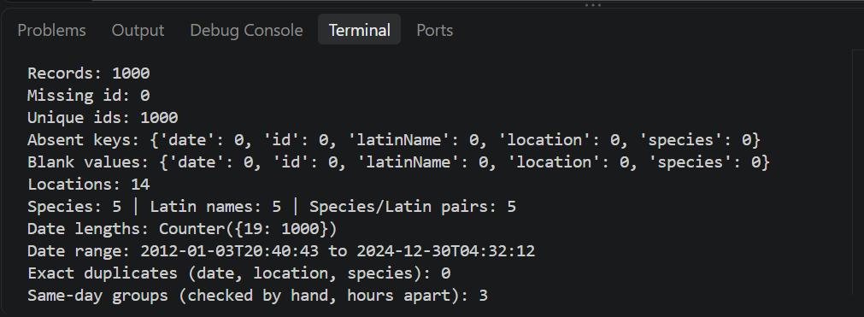
What I found in the data
I checked the data before building the cleaning rules (the checks are shown in Figure 1):
- All five fields are present in all 1000 records.
- There are 1000 unique IDs.
- There are 14 locations, all spelled consistently.
- Each species has exactly one Latin name (5 species, 5 pairs).
- Every date is in the same format, so none of the records were rejected.
- No two records have the same date, location and species.
Figure 2
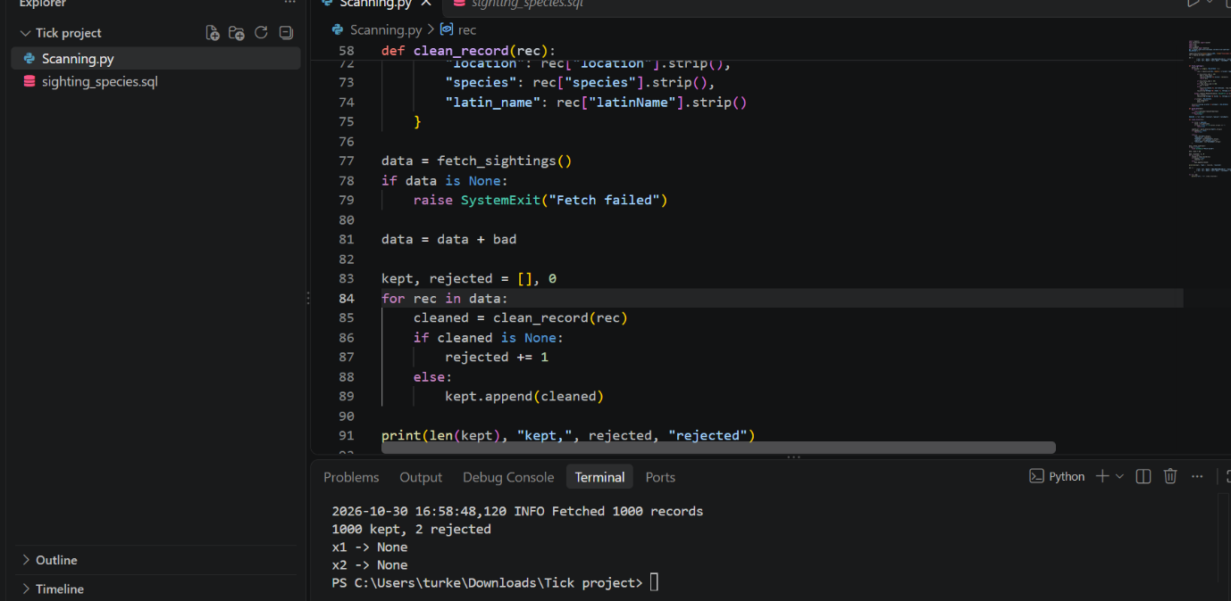
Testing the cleaning rules
Because the real data had nothing to reject, I tested the cleaning rules by adding two deliberately bad records to it: one with a blank location and one with an invalid date. Both were rejected (the cleaning function returned nothing for them), and all 1000 real records passed, giving 1000 kept, 2 rejected, as shown in Figure 2.
Figure 3
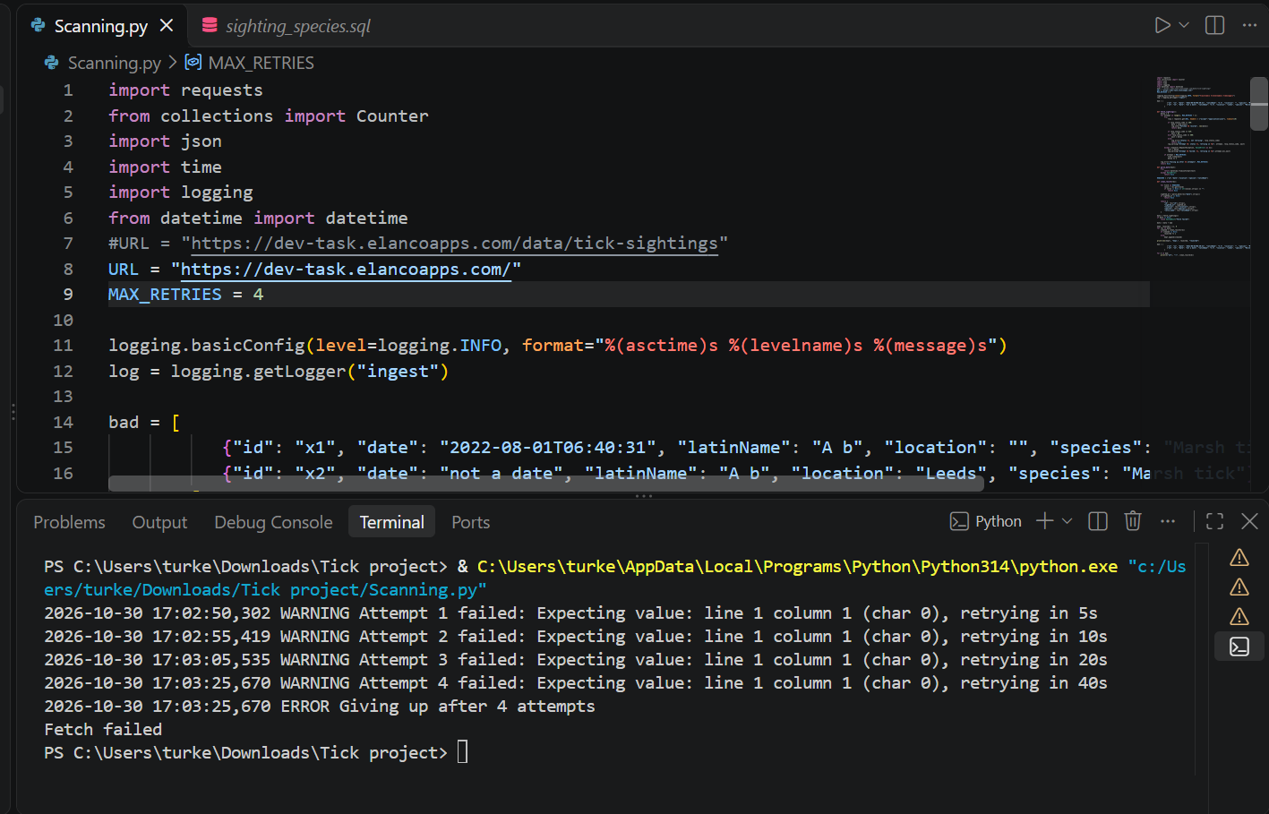
Handling API failures
I built a function called fetch_sightings to handle failures when calling Elanco’s API. If the request fails, or the response isn’t valid data, the error is caught and the function tries again, waiting longer each time (5, 10, 20, then 40 seconds), instead of crashing the script. If Elanco’s API says I’ve sent too many requests, it waits a minute before trying again. After four failed attempts it gives up, logs what happened and stops cleanly, so nothing half-loaded ends up in the database.
To test this, I pointed it at a web page that doesn’t return data. The log in Figure 3 shows each retry with its growing delay, followed by “Giving up” and a clean stop.
Figure 4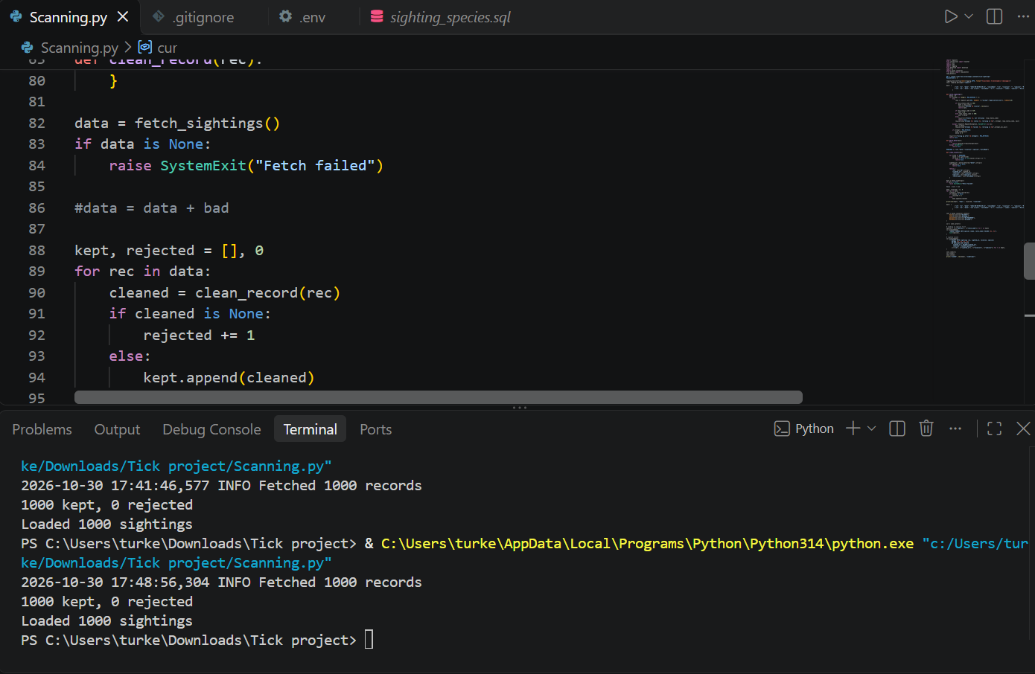
Figure 5
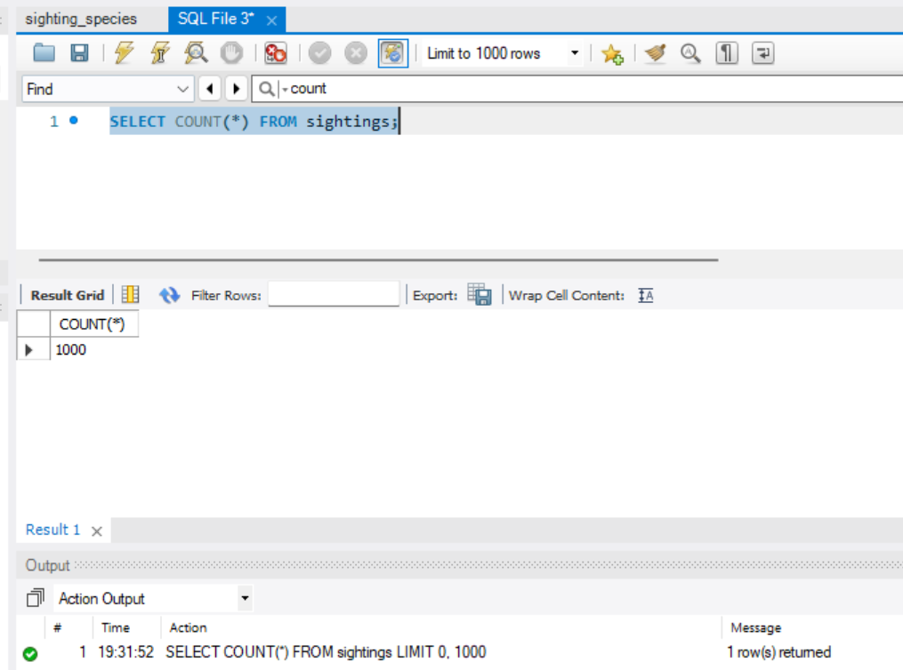
Loading the data
I load the species first, then the sightings. Species goes first because each sighting points at its species through a foreign key, so the species row has to exist before the sighting that references it, or MySQL rejects the insert.
Each species is inserted once using INSERT IGNORE, which skips a species that’s already in the table. A plain insert would fail on a second run. Sightings are loaded with ON DUPLICATE KEY UPDATE (an “upsert”). If a sighting’s ID already exists, that row is updated instead of added again, so running the data_cleaner twice never creates duplicates.
I tested this by running it twice. The row count stayed at 1000 both times, as shown in Figures 4 and 5.
The trade-off is that the upsert overwrites existing rows with the latest data, so there’s no history of changes. A production version might keep one.

Application 2 (API query)
The two files in the API
app.py deals with web requests. It reads the query parameters, checks them (dates, limits and the allowed options), chooses the right function, and returns the result as JSON, or a clear error if something is wrong.
db.py is a data access layer. The routes call its functions and never touch SQL, so the database details are hidden behind them. I didn’t build a formal interface with multiple implementations because there’s only one database.
Handling bad input
If a request has a bad value, such as a made-up option or an invalid date, the API returns a 400 error (meaning the request was wrong) with a message saying what’s allowed. If the ID doesn’t exist, it returns a 404 error (not found) with a message. The number of results per request is capped at 1000, so nobody can ask for the whole database in one go. Figure 6 shows the error messages.

Figure 6
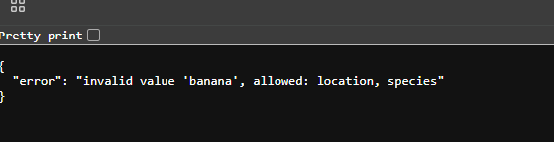

Figure 7
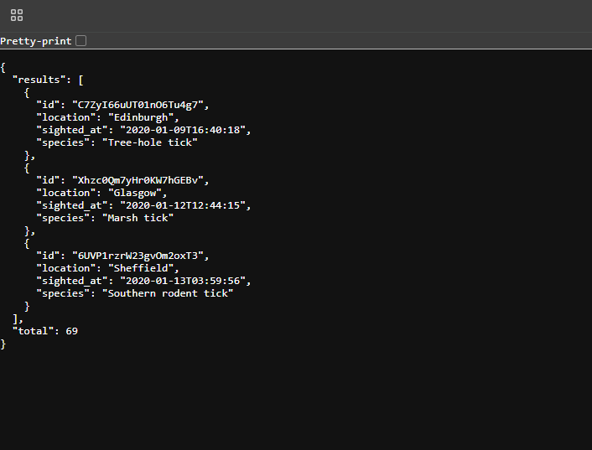

Design choices in db.py
One filter class. The filters (location, species, start, end, limit and offset) live in one small class called SightingFilter. Every endpoint builds one and passes it down. The alternative was passing each filter separately, or reading the request directly inside the query code. Because the list, summary, trends and seasonal endpoints all accept the same filters, the filtering logic is written once, in build_where.
Enums for fixed choices. The group-by choice (location or species) and the period (week or month) are Enums, meaning a fixed list of allowed values. The alternative was to accept any text and check it with if statements, or to put the user’s text straight into the query. With an Enum, only the allowed values can ever reach the SQL, and a bad value gets a clear error, as in the “banana” test in Figure 6. I didn’t use Enums for city and species, because a fixed list would go stale the moment a new city appeared, so those are passed as ordinary values. An unknown city just returns no results.
Safe queries. User input is always passed as query parameters and never inserted into the SQL text, which prevents SQL injection (where someone types SQL code into a field to change what the query does).
Two queries per list. Each list runs a separate count query as well as the query for the page itself, so a client knows the total number of results and can page through them.
Indexes. I added indexes on date, and on location plus date. They support the main filters and keep them fast as the table grows.
Seasonal average. The seasonal average divides by the number of years the data covers, so months with no sightings in some years count as zero.

Figure 8
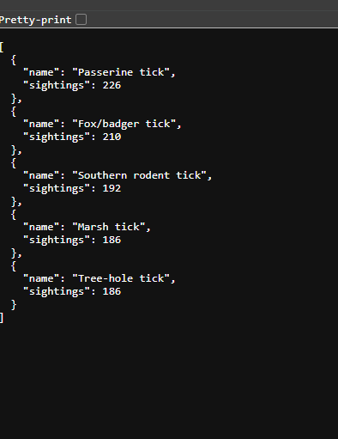
The /summary endpoint, showing the number of sightings per city. The counts add up to 1000, matching the total number of records loaded into the database.

Figure 9
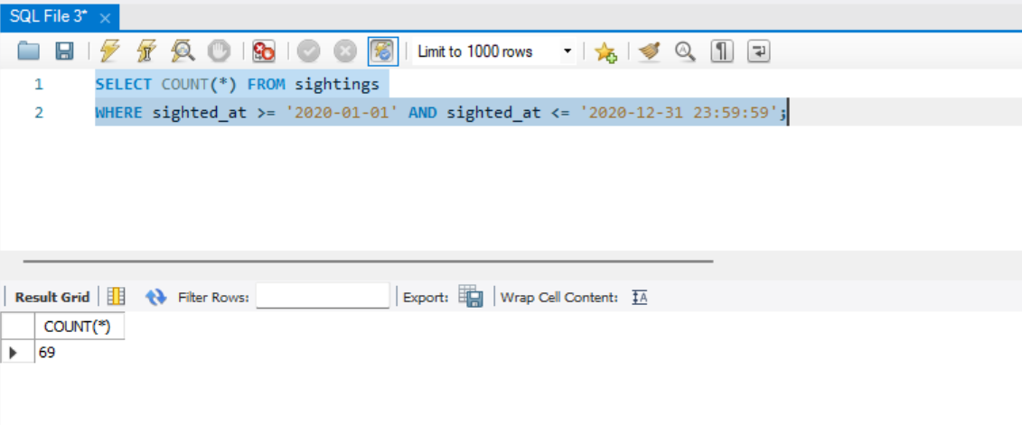
A direct MySQL query counting the sightings from 2020. It returns 69, matching the total in Figure 7.

Regions
The data only records cities, so I group them into UK regions using a fixed lookup in the code (for example, Manchester and Liverpool are both North West). Scotland and Wales appear as their own areas. With more time I’d store this in a locations table with a region column, since region depends on location for example Figure 10:
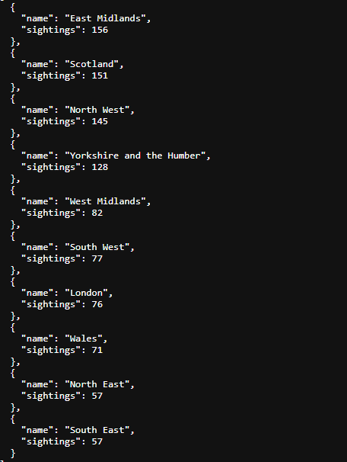/summary?group_by=region, the sightings grouped into regions; the counts add up to 1000

What I would do with more time
- AI/ML insights. With more time I’d add anomaly detection on the weekly counts per city, flagging weeks well above that city’s normal level, and a simple forecast of monthly sightings. This sample data is spread almost evenly across months and cities, so I’d expect a model to find very little in it. I’d want real-world data which should show a spring and summer peak, before drawing conclusion.
- Schedule the ingest. Run it daily with a schedular and call the stats endpoint first so full sync only happens when total_sighting has changed.
- Fallback duplicate rule. Flag the same location and species within about five minutes as a likely duplicate, implemented by grouping and sorting, not by comparing every pair. The sample didn’t need it
- Validate city and species against the database, so a typo gets a clear error instead of an empty list
- Scale. Cleaning is linear and fast, but at larger volumes. I’d load in batches and only upsert new or changed records. I’d switch to pandas for heavier transformation.
- Fill gaps in trends so months with no sighting show as zero and add index on species for the species filter.
- Production setup. Use a proper web server instead of Flask development one, with debug off, a connection pool, and authentication and rate limiting on the API.
- Keep rejected records. Store them in a separate table with the reason each was rejected, so nothing is silently dropped and the rejection counts can be audited. I choose to count them instead for the MVP.

